Write a program to traverse a graph using BFS method.
#include <stdio.h>
int graph[20][20], visited[20], n;
void BFS(int start) {
int queue[20], front = 0, rear = 0;
visited[start] = 1;
queue[rear++] = start;
while (front < rear) {
int node = queue[front++];
printf("%d ", node);
for (int i = 0; i < n; i++) {
if (graph[node][i] == 1 && !visited[i]) {
visited[i] = 1;
queue[rear++] = i;
}
}
}
}
int main() {
int start;
printf("Enter number of vertices: ");
scanf("%d", &n);
printf("Enter adjacency matrix:\n");
for (int i = 0; i < n; i++)
for (int j = 0; j < n; j++)
scanf("%d", &graph[i][j]);
for (int i = 0; i < n; i++)
visited[i] = 0;
printf("Enter starting vertex: ");
scanf("%d", &start);
printf("BFS Traversal: ");
BFS(start);
return 0;
}
OUTPUT
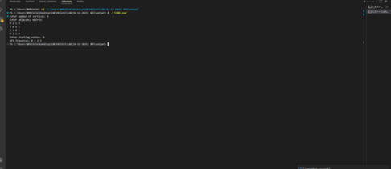

LAB PROGRAM 9B
b) Write a program to check whether given graph is connected or not using DFS method.
#include <stdio.h>
int graph[20][20], visited[20], n;
/* DFS function */
void DFS(int v) {
visited[v] = 1;
for (int i = 0; i < n; i++) {
if (graph[v][i] == 1 && !visited[i]) {
DFS(i);
}
}
}
int main() {
int start = 0, connected = 1;
printf("Enter number of vertices: ");
scanf("%d", &n);
printf("Enter adjacency matrix:\n");
for (int i = 0; i < n; i++) {
for (int j = 0; j < n; j++) {
scanf("%d", &graph[i][j]);
}
}
/* Initialize visited array */
for (int i = 0; i < n; i++) {
visited[i] = 0;
}
/* Start DFS from vertex 0 */
DFS(start);
/* Check if all vertices are visited */
for (int i = 0; i < n; i++) {
if (!visited[i]) {
connected = 0;
break;
}
}
if (connected)
printf("The graph is CONNECTED.\n");
else
printf("The graph is NOT CONNECTED.\n");
return 0;
}
OUTPUT
